BECOME A CERTIFIED TAROT READER

MODULE ONE
INTRODUCTION TO TAROT

UNDERSTANDING TAROT
Have you ever wondered "what exactly are Tarot cards?" You are not the only one with such thoughts, many people also wonder same. Other questions from random sampling are;
- "Can Tarot cards really foretell one's future accurately?"
- "Can reading Tarot cards be learnt?"
- "Is there a requirement to being able to read them?"
- "What makes them different from the normal playing card?"
All of these questions are really not baseless, it is merely an expression of curiosity which is totally fine. Since time memorial, the ancient and mystic pack of cards called Tarot has never failed to spark curiosity in the minds of people who are not in practice. While you read through this course, these questions and others you may have will be duly answered.
In a Tarot you will find 78cards, of which 56 (in like fashion of the modern cards) are equally divided among four suits namely; Wands, Cups, Swords, Pentacles. This is in equivalent to Clubs, Hearts, Spades, and Diamonds which is seen in modern cards. These suit cards are known as the Minor Arcana (arcana is the Latin word for secrets). Then there is the 22 left in the pack called the Major Arcana; these are cards that depict symbolic figures, elements in nature, the experiences of Man in his spiritual journey, his hopes and fears, his joys and sorrows.
The Major Arcana, as you would later see in this course, have very little likeness to modern cards. The images you will find on them are illustrations drawn from different universal symbols and images of legends, myths, philosophies, religions, and magic beliefs of the human race. History has it that, Tarots was passed down from over seven centuries through wise men and seers who were well read in astrology, numerology, and Kabalistic teachings of the ancients. It is believed that this is what accounts for these influences which are reflected in the cards.
The Tarot, nevertheless, remains a unique and independent discipline with its own divinatory powers and its own spiritual content. It is sure beyond the illustrations on a pack of cards. Due to the spiritual potency of the Tarot cards, many people have been seen to draw interest in analyzing the characters on the cards, some seek a glimpse of their future through it and then there are some who use its powers to divine solutions to their current state of dilemma. The Tarot is many things to many people but it is crude to helping people find what their hearts truly seek and desire.
The usual format to get a reading is to consult an experienced “Reader” for help, which makes you the “Querent,” with an unspoken question you want answered. The reader lays out the cards in a particular format and then interprets what the cards are trying to communicate to you. In this course you will learn the art of being a reader yourself and then get certified for such. However, mastery comes through practice and consistency.

A BRIEF HISTORY ABOUT TAROT
The true Tarot is majorly about symbolism. There is a definite form of language that is being communicated through the reading of the cards, this is said to have risen from the mind of Man in a collective manner. The ability to harness the powers and wisdom from the cards is a given to those who seek to decipher the in-depth meaning of the symbols on the cards. This is not for the basic person, but for those seeking all the card yields and willing to commit to the highest degree. Till date, the different versions of the origin of Tarot makes it difficult for one to conclude which is the final truth. Although through observation, one can deduce what century and from which land it came from, but not the person who invented it. These theories only put us on a path illuminated by new discoveries.
The details of the history of Tarot as then be modified through time by persons who have committed to its history. Some of these people are artist, some are academicians, specifically historians. Therefore, for such a history shadowed by a lot of new discoveries, it is normal to have lots of myths surrounding its origin. It is safe to say the better way to remain is open, to all the known ideas around the origin of Tarot. Making no assertions allows you to see the perspectives of other people. This is indeed needed for the sake of clarity and flexibility. One of the things the different myth also birthed is different cult associations. One Tarot, but different views and for those who take it into assertive convictions, they form a cult to further their claims on its origin and other characteristics.
One of the oldest ideology surrounding the understanding of the origin of Tarot is linked to the Gypsies. They say that the hidden knowledge and secrets of the Tarot was first brought by them from Chaldea and Egypt and then into Israel which further ended up in Greece. Wild researchers around the world have shown that this theory may not be false. When you think or research back, it is true that the Gypsies where indeed large in number in Europe at about the same time that the Tarot cards began to be used around the shores of the Mediterranean.
Another very old but fascinating story which links the origin of Tarot to Egypt is related to the destruction of the great library. If you are a good student of history you might remember the great library located at Alexandria in the city of Fez, and how it was destroyed. Fez is now known geographically to be Morocco, at that time Fez was known to be the city hosting the greatest intellectuals of that time. History has it that these intellect wanted to set method of communicating, as this was a big barrier due to the multi-cultural diversities of people speaking different languages. In this light, they all invented a book with many pictures of mystic symbols. Then the secret to unlock the meaning of the signs and symbols was passed down from a generation to the next. All of whom are part of an initiation cult. The handover was done by word of mouth all these while until a time when there was a need to preserve the secrecy of these messages passed down. Then they created cards which was used majorly as sport for many who do not know the original significance of the symbols on the cards.

Then also was the theory of Thoth who was at the time one of the counselors to Osiris. Thoth was said to have invented Tarot, he was a scribe of many feathers. Amongst these are; the Egyptian gods, measurer of time, inventor of numbers, and the god of wisdom and magic. This theory was even made more concrete by the method used in the initiation ceremonies for Egyptian priesthood. Many have said the symbols on the Major Arcana is a major part of the initiation process. When you see the images later in this course, one can really tell that they must have an origination from Egypt.
There is also a close link to the Kabalistic teachings of the ancient Hebrews. In summary, it is certain that the person who invented the Tarot was well grounded in philosophes, ancient religion and could embody many symbols on the card. Many have argued that the actual meaning of these cards have been lost at the time when it was used in telling fortunes as a form of trade.
In England, the Tarot was known in the reign of Edward IV (fifteenth century). The king forbade the importation of the cards; nevertheless, the Tarot found its way from the caravans of the Gypsies into the homes of the nobles, where it was kept hidden for fear of reprisals. After the French Revolution, a new freedom swept Europe; esoteric sects and mystic lodges flourished once again. In the eighteenth century, the illustrious French scholar Court de Gébelin, who was the first to suggest that the Tarot might be of Egyptian origin, unearthed the Tarot cards while doing research for his many-volumed works. Gébelin’s rediscovery came at a time when people were interested in Rosicrucianism, Masonry, the Kabalah, and Astrology. The climate was propitious for the Tarot and its mysticism to reenter the occult thought of the day.

MODULE ONE QUIZ
- How many cards are in a set of Tarot?
- 72
- 78
- 82
- 56

- Tarot is divided two Arcana, Which are?
- Main and Sub
- Major and Main
- Main and Minority
- Major and Minor

- The Minor Arcana is further divided into four suits namely
- Wands, Cups, Swords and Pentacles
- Clubs, Hearts, Spades, and Diamonds
- Wands, Cups, Spades, and Pentacles
- Clubs, Cups, Swords and Pentacles

- Arcana is a Latin word that translates to English as?
- Idols
- Treasure
- Secret
- Hearts

- The one who has come for enquiry from an experienced Tarot reader is called?
- The Reader
- The Curious
- Mind Reader
- The Querent

MODULE TWO
MAJOR ARCANA

INTRODUCTION
The Major Arcana is comprised of 22 cards, with a wide range from the fool to the world. Some persons have considered the Major Arcana as the most important of the Tarot deck of cards. This may be because the illustrations are quite rich in symbolic and mythological figures, animals, natural phenomena and objects. When one gets a high number of these cards in a spread, it is always an indication of something important to the Querent. Below are the different meaning of the cards and how they look like illustratively.

S/N | CARD | MEANING
1 | 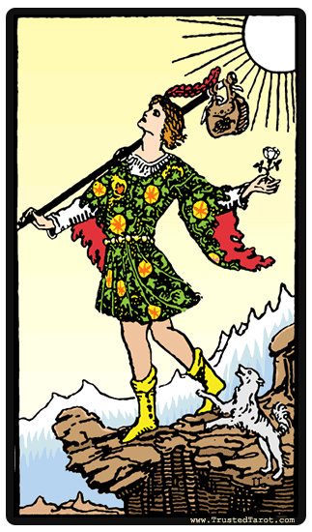  THE FOOL | Depicts the discovery of one's hidden talents. Points to a personal growth, a new experience following a risk that must first be taken. An abandonment of the old life in exchange for the new phase of life which shall usher in new developments.
2 | 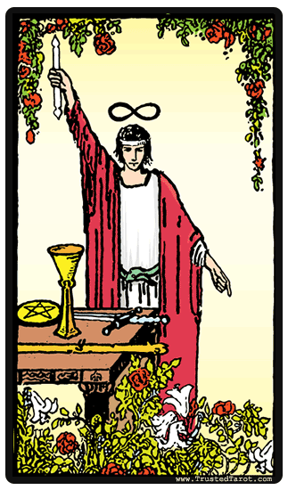  THE MAGICIAN | The guarantee of success in everything when there is a full optimization in the use of the available skills, tools and resources. Shows the possibilities and potential in growing and the pursuit of adventures. Definitely unlocking the doors to new opportunities.
3 | 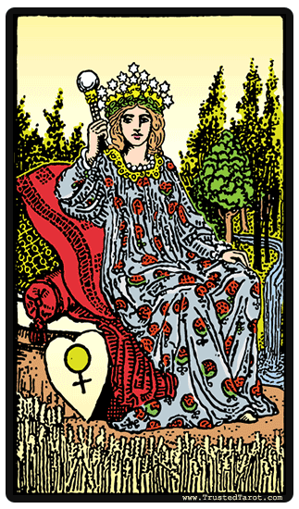  THE EMPRESS | A mother, of all things fertile and of growth. Speaks to a marriage or relationship or motherhood or pregnancy or just the need for patience. Brings to life the birth coming into a situation or a new path of life.
4 | 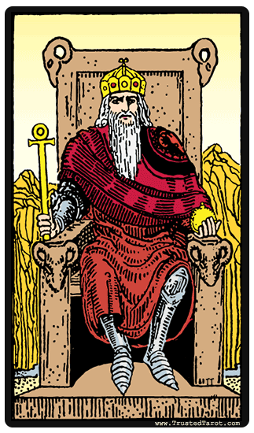  THE EMPEROR | Shows control, dominance and authority of a man, an employer or one in a place of authority. Identifies with the need to solidify an idea or concept in building a more firm structure.
5 | 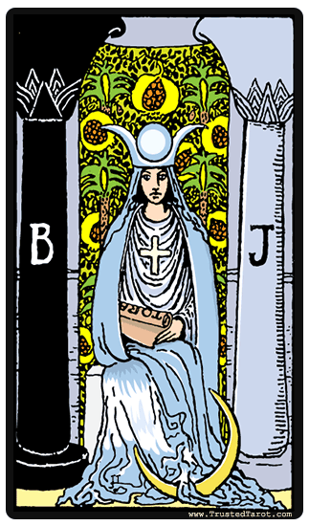  THE HIGH PRIESTESS | A reflective time to usher in revelations of deep secrets or potentials yet untapped. Applies to a state that calls for a need to pay attention to one’s dream and intuition, to understand the possibilities in their meaning and interpretation.
6 | 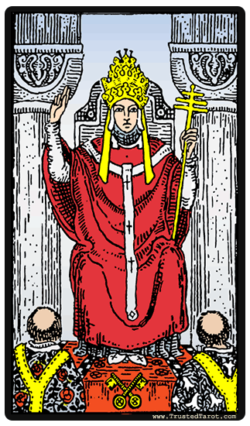  THE HIEROPHANT | A dedication to learning and a call for a divine purpose. It can be a commitment to a higher purpose which can be marriage or a religion. Points to a purpose beyond the individual but a sacred and divine one.
7 | 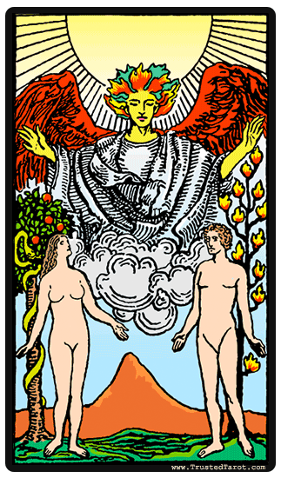  THE LOVERS | To be presented with different choices which calls for the need to pick the right one. The choices we make being the guide of our life's path makes this important and significant. Speaks of intuition over intellect as a base to true partnership.
8 | 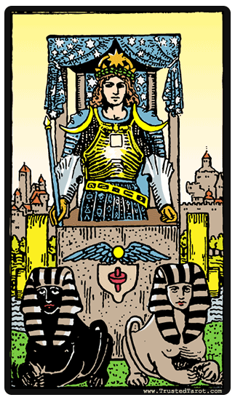  CHARIOT | The advent of one's struggles and battles with potential for victory, resolution of quarrel. Hence, a forward movement is envisaged after overcoming oppositions in confidence.
9 | 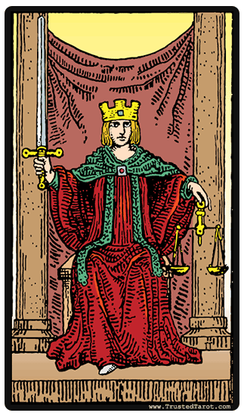  JUSTICE | The balance needed in making a fair decision. The need for a clear mind that can pass impartial judgment. An accountability measure for all actions and decisions in every area of life. This can also mean the need to pay attention to one's legal matters (Marriage license, financial arrangement, divorce decree and so on).
10 | 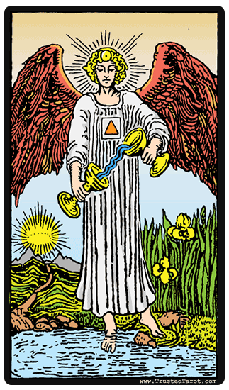  TEMPERANCE | At peace in a partnership or relationship, even marriage. Shows the need to adapt, coordinate and still external forces in patience and moderation.
11 | 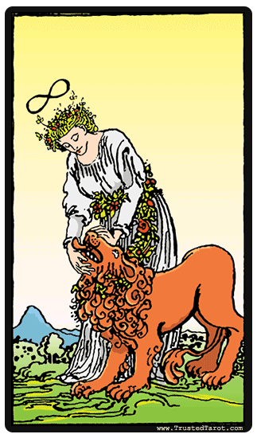  STRENGTH | Shows optimism as one faces one's fears which may be the truth in a particular situation. Going in afraid and still positive as courage is needed.
12 | 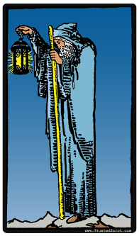  THE HERMIT | Speaks to the need for solitude, a walk away from what is common or usual. A time to withdraw to one's inner self or a call for meditation.
13 | 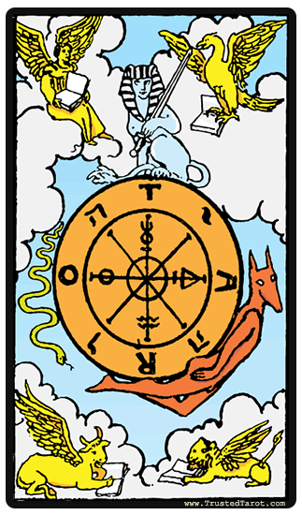  THE WHEEL OF FORTUNE | A new turn with the promise of new beginnings. An optimistic view to keep one's faith in the universe and trust that all will work out well.
14 | 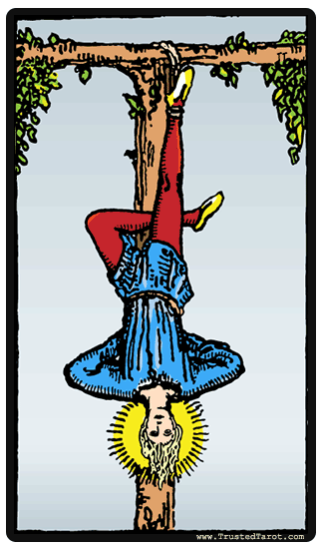  THE HANGED MAN | The need for one to make sacrificed for the new possibilities and opportunities to flood into one's life. This sacrifice might just be about being still and waiting for those possibilities to show up or to adapt to the change in circumstances. The will to adapt is the main characteristics of this card.
15 | 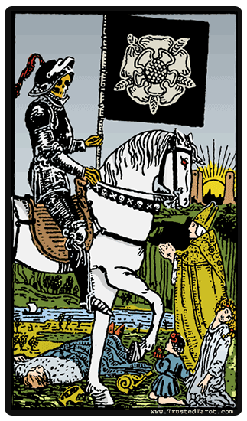  DEATH | The meaning of this card can be very confusing. It can mean the end of a thing which has lived out its purpose or use. It can also point to a significant change or transition to a new beginning. Death usually is not about the end of it all but a time to be transformed into something new.
16 | 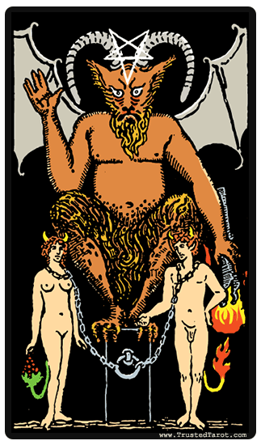  THE DEVIL | Points to one's inner struggles with the unfavorable situations one may find oneself in this world. It may be a bad habit or an unhealthy relationship. The devil is a representation of all things bad in this world that relates to us as humans.
17 | 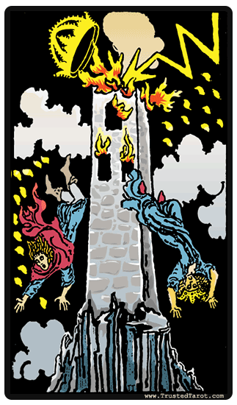  THE TOWER | Depicts the greater good that can come from great conflict and overall disruption in life. The need to break off existing structures that are false and create a new order of true values. It is a challenging period that promises greatness.
18 | 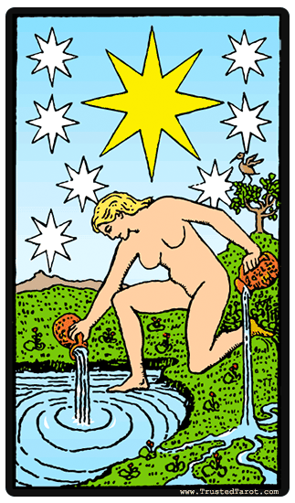  THE STAR | Struggling with making a decision or taking an action or shying away from the possibility of one's choices leading to a good or bad path. With such confusion, fluctuation and much certainty, the choice or decision is still a need and must be done regardless.
19 | 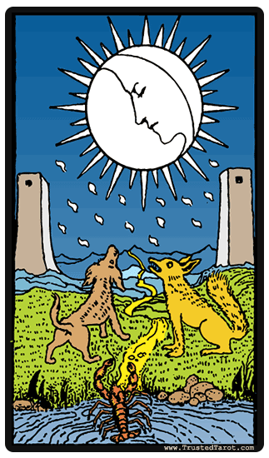  THE MOON | A passive time showing the need to be more intuitive and act less. Creating mental energies that reinforces ones optimism as the card point to the forces from psychic world for a clear view on the future.
20 | 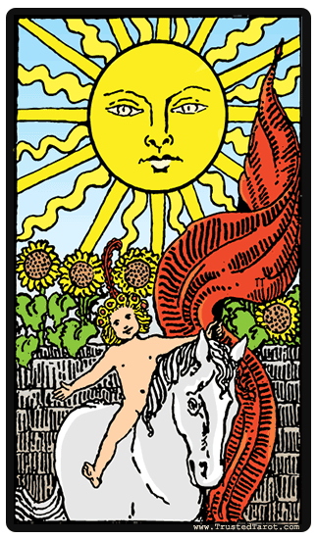  THE SUN | The brightening of a destiny and giving it all you have got to make a worthy achievement. Points to happiness, success, good health and a warm season that is favorable.
21 | 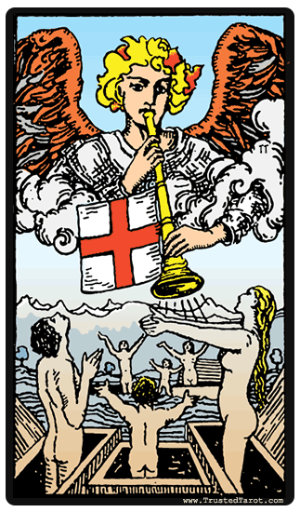  JUDGEMENT | This is the harvest card for the choices one has made. It can point to the need to learn from one's past experience and then be reborn or renewed through such lessons.
22 | 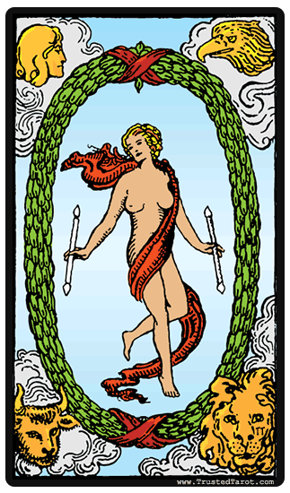  THE WORLD | This cards speaks to the embrace from people in the world, being welcomed anywhere you go.

MODULE TWO QUIZ
- How many cards are in a Major Arcana?
- 21
- 32
- 56
- 22

- Which of the cards points to trusting the universe to work things all well?
- The Star
- The Hanged Man
- The Wheel of Fortune
- Death

- Which card points to reaping the product of one’s choices?
- Strength
- The Empress
- The Emperor
- Judgment

- Which card points to the need for dominance or a show of control?
- The Emperor
- The Magician
- The High Priestess
- The Moon

- One of the meaning of the card “The World” is?
- To be intuitive
- To be treated hospitably by people from different geographical location.
- To reap the product of one’s choices
- To live like a magician

MODULE THREE
MINOR ARCANA

INTRODUCTION
Many people believe that the Minor Arcana is even more ancient than the Major Arcana just like some others believe the Major Arcana is of more importance to our life as a whole than the Minor Arcana. As we mentioned earlier, the best disposition to all of these is to remain open. The Minor cards cover emotions, imaginations, stress and need of an individual, but majors on the current activities in this regard. The Minor Arcana are 56 in number (including the Court Cards), all highlighting the practical aspect of our lives.
The Court Cards within the Minor Arcana are; Page, Knight, Queen and King. The use of these cards is mostly represented by individuals; our entire being, our thoughts, other people in our lives and their personalities, and lastly is our level of maturity. All of these relate to behavior or situations in some cases. Here are the primary crude meaning of the court cards;
- PAGES conceive ideas
- KNIGHTS act upon ideas
- QUEENS nurture ideas
- KINGS develop ideas to an established and stable state
Minor Arcana is made of four suits with each suit containing cards numbered from ace to ten, plus four Court cards: King, Queen, Knight, and Page. The similarity between the Minor Arcana in the deck of Tarot cards and the modern deck is enormous. With the exceptions of Knights, the suits name can be changed in the following order;
- Wands to Clubs
- Cups to Hearts
- Swords to Spades
- Pentacles to Diamonds
If this is done, the remaining card would basically be an identical with the modern deck many play with. Also there is the unnumbered fool which matches the Joker in the modern deck. The joker is also an unnumbered card. Each suit has a holistic meaning, which would be explained below;
- Wands: This suit shows animation, creativity and enterprise that requires energy and growth.
- Cups: This suit generally betokens pure love and untanned happiness. It is mostly associated with feelings and emotions.
- Swords: The swords generally express aggression, strife, boldness, and courage. These are basically issues of an individual’s life, things we all have to face. In some cases, this suit can be used to represent hatred, misfortune, disaster, battle, and enemies.
- Pentacles: The symbols on the cards are referred to have pentacles, which are metal disks with a lot of ancient magical formulas as inscription. The illustrations shows that the pentacles are inscribed with the five-pointed star referred to as the pentagram.
THE SUIT OF WANDS
S/N | CARD | MEANING
1 | 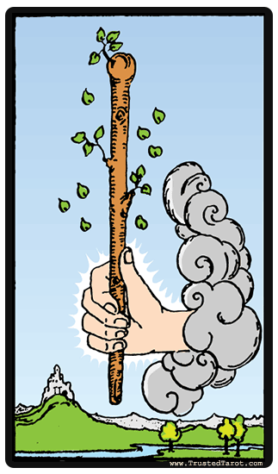  ACE OF WANDS | Beginning of an enterprise, invention, or the beginning of a family. Perhaps the beginning of a journey, an adventure, an escapade.
2 | 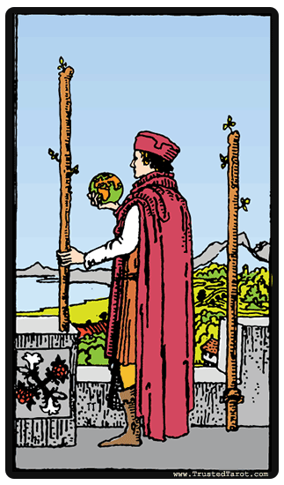  TWO OF WANDS | Boldness, courage in embarking on an enterprise. The employment of scientific methods. Influence over another. Kindness and generosity—yet a proud and unforgiving nature.
3 | 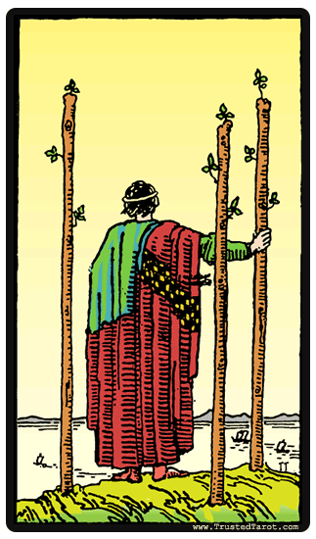  THREE OF WANDS | Realization of hope, established strength, nobility, wealth, power. Caution against pride and arrogance. Partnership. Help will be offered by a successful merchant.
4 | 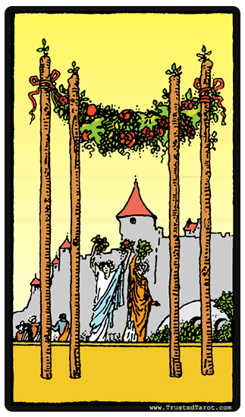  FOUR OF WANDS | Perfected work; rest after labor. Peace, prosperity, harmony. Romance, a coming marriage.
5 | 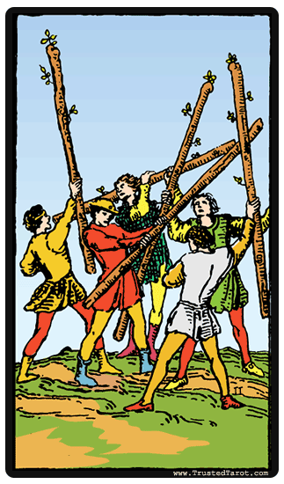  FIVE OF WANDS | Violent strife, rashness, competition. In the battle of life, boldness changes things for the better. Obstacles. Lawsuit.
6 | 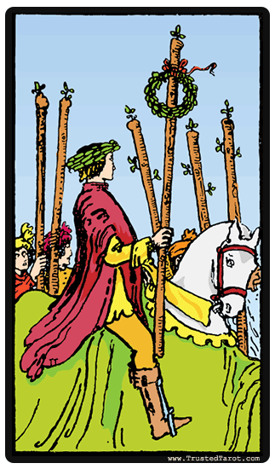  SIX OF WANDS | Good news. Victory after strife. Pleasure gained through labor. Success through industry. Advancement in the arts and sciences. Friends are helpful.
7 | 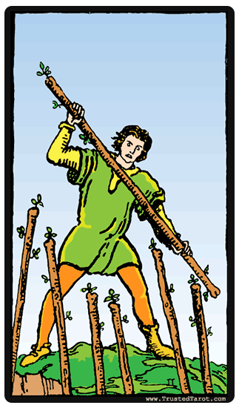  SEVEN OF WANDS | Victory through courage. Success against opposition. The Querent has the position of advantage. Competition in business or trade. Certain success.
8 | 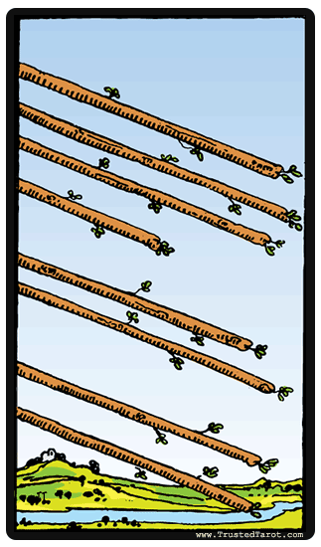  EIGHT OF WANDS | Great haste, great hope, too rapid advancement. That which is on the move. Hasty communication. Messages, letters of love. Approach to a goal. Journey by air.
9 | 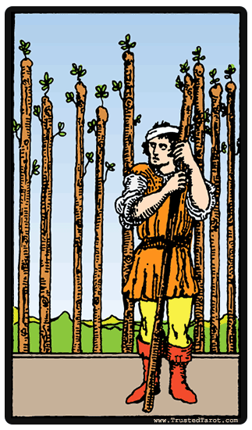  NINE OF WANDS | The pause in a struggle. Preparedness, strength in reserve. Eventual victory but steady force must be applied. Obstinacy, strength, power, health
10 | 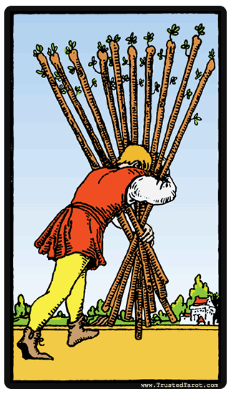  TEN OF WANDS | Force and energy applied to selfish ends. Power unwisely used. Carrying a burden of ill-regulated power. Here is also a refining test by fire, the heart tried by pain. Problem soon to be solved.
11 | 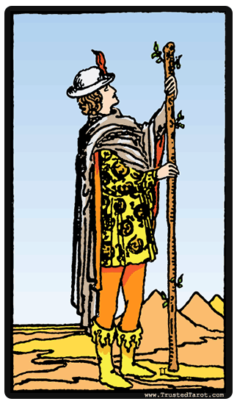  PAGE OF WANDS | Courage, beauty. A nature sudden in love or anger. Desire for power; enthusiasm. A messenger or postman. A bearer of tidings. If this card appears in a spread next to one representing a man, there will be favorable testimony concerning him.
12 | 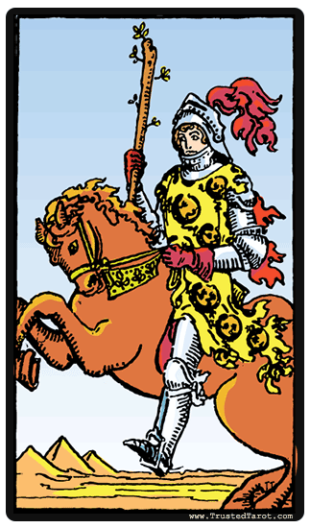  KNIGHT OF WANDS | A young man, possibly a warrior, filled with energy. He can be a generous friend or lover, but is also likely to be cruel and brutal. He is hasty in all he does. May also mean change of residence, emigration, quick departure. Knights in a spread may also mean the coming or going of a matter.
13 | 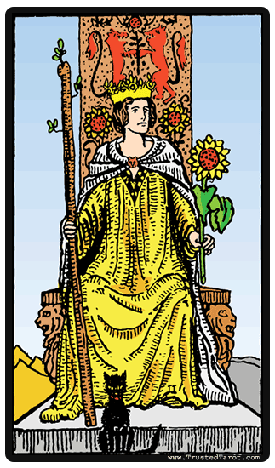  QUEEN OF WANDS | She has great power to attract that which she wants, and is fruitful in mind and body. Loving nature and her home, she is practical with money and sound in her business judgments. If she does not represent a woman, then she represents these qualities: success in undertakings; love of home and growing things; kindness and generosity.
14 | 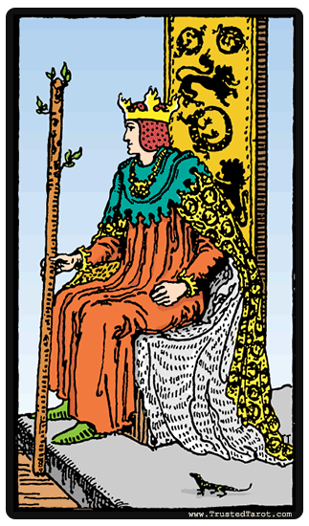  KING OF WANDS | Handsome and passionate, he is agile in mind and body. A country gentleman, generally married. Loyal and noble, he comes of good family. Sometimes he is too hasty. If no man seems to be involved in the spread of cards, you will find these traits: honesty, friendliness, passion. The card may mean unexpected heritage; a good marriage.

THE SUIT OF CUPS
S/N | CARD | MEANING
1 | 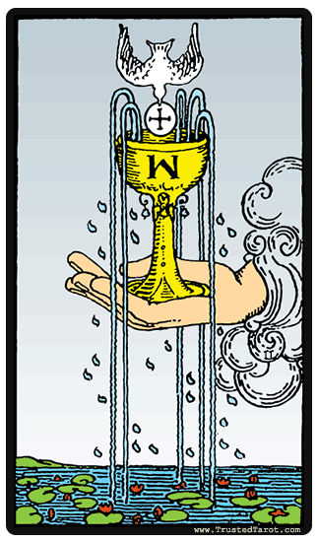  ACE OF CUPS | The beginning of great love. Joy, contentment. Productiveness, fertility. Beauty and pleasure. A reminder that when the mind is filled with Spirit, the Spirit will fill the material cup to overflowing.
2 | 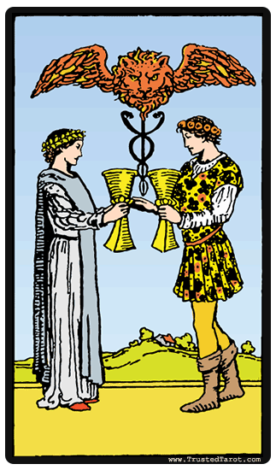  TWO OF CUPS | Harmony of the masculine and the feminine. Reciprocity, the beginning of a friendship or love affair. Balance of ideas and plans with a kindred soul.
3 | 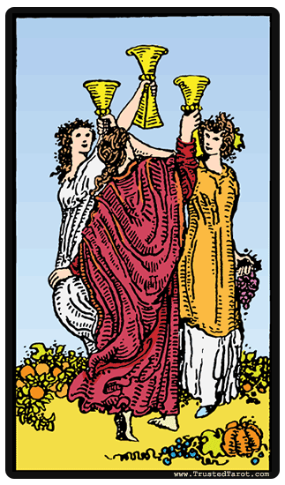  THREE OF CUPS | Success, abundance. Good luck, fortune, victory. Happy issue of an undertaking. Hospitality. Pleasure.
4 | 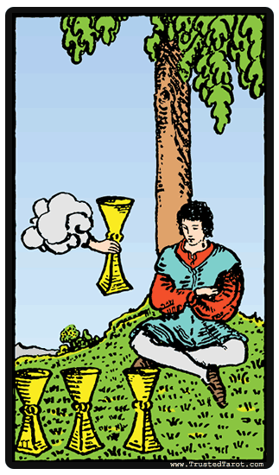  FOUR OF CUPS | A stationary period in one’s life; weariness, surfeit. Dissatisfaction with material success. Reevaluation of one’s earthly pleasures. Kindness from others.
5 | 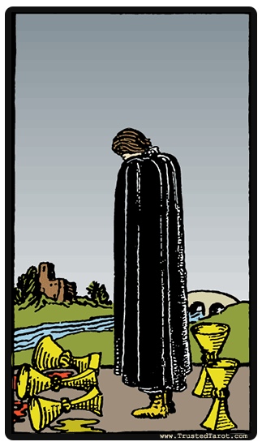  FIVE OF CUPS | Disappointment. Sorrow in those things from which pleasure was expected. Disillusionments in love. Marriage broken up. Loss of friendship. Vain regret; loss, but with something left over.
6 | 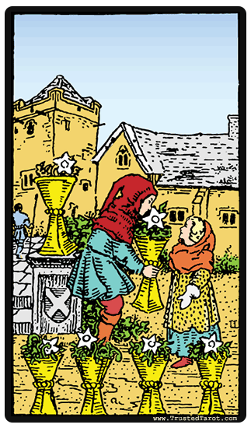  SIX OF CUPS | Happiness, enjoyment, but coming from the past. Meeting with a childhood acquaintance. Pleasant memories. Or this card may mean new friendships. A gift from an admirer. New knowledge and new opportunities.
7 | 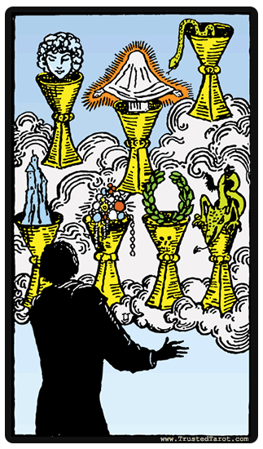  SEVEN OF CUPS | Dreams, castles in the air, an imagination that has been working overtime. The seeker’s forces have been too scattered. Illusionary success. Selfish dissipation; deception.
8 | 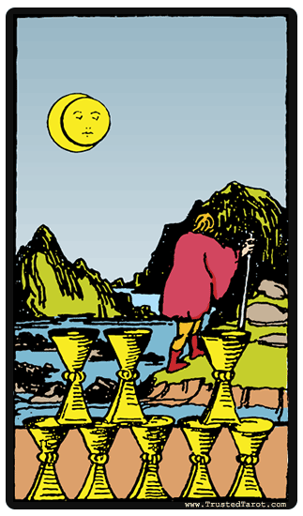  EIGHT OF CUPS | Things thrown aside as soon as gained. Journeying from place to place. Misery and repining without cause. Disappointment in love. The seeker may desire to leave material success for something higher. Success abandoned.
9 | 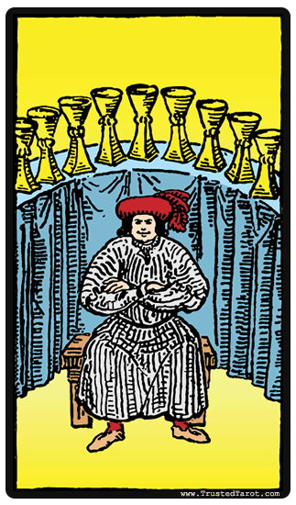  NINE OF CUPS | Material success, satisfaction. All the good things of life are available. The Querent will get his wish. Physical well-being.
10 | 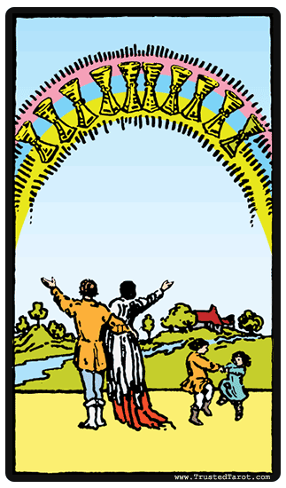  TEN OF CUPS | Contentment. Lasting happiness because it is inspired from above rather than being the sensual satisfaction indicated in the Nine of Cups. Perfection of human love. Great friendship. Lasting success. Peacemaking.
11 | 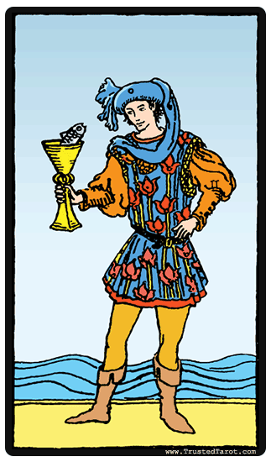  PAGE OF CUPS | A melancholy and passionate youth, studious but given to flights of imagination. Willing to render service to the Querent. If this card does not signify a youth, it will mean the Querent is drawn to the arts, is given to meditation. News, a message, perhaps the birth of a child. New business methods proposed.
12 | 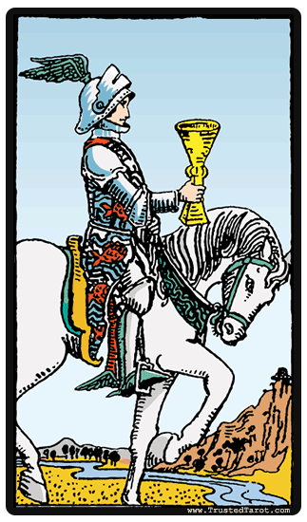  KNIGHT OF CUPS | A young man who is graceful, poetic, but indolent. He is a dreamer of sensual delights. Can mean the bringer of a message, a proposition, or an invitation.
13 | 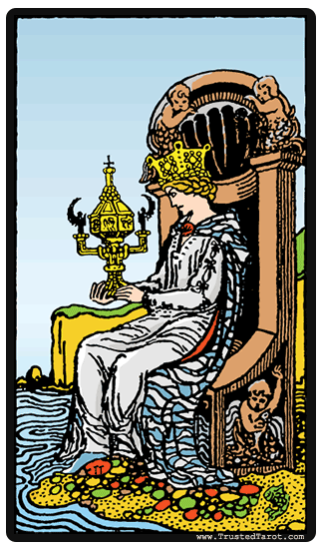  QUEEN OF CUPS | A woman who is able to put into practice what her visions decree. She is the good wife and mother—honest, devoted, and loyal. If the Querent does not recognize such a woman in his or her life, then someone with vision should be considered, or someone who is kind though not willing to take too much trouble for another. Success, happiness, pleasure are indicated
14 | 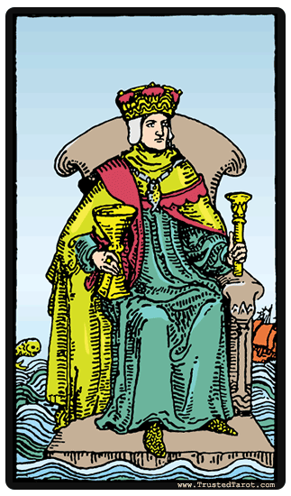  KING OF CUPS | This man is skilled in both law and trade. He may be connected with either a church or a worldly institution. He is kind and considerate and willing to take responsibility. If such a man is not indicated, then look for traits of liberality, generosity, consideration, creative intelligence, and interest in arts and religion.

THE SUIT OF SWORDS
S/N | CARD | MEANING
1 | 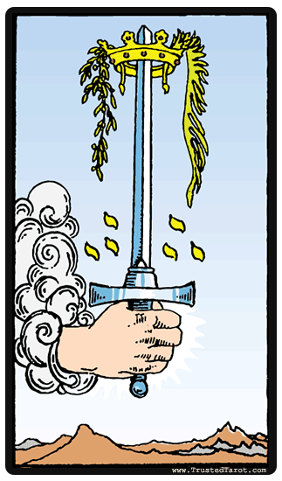  ACE OF SWORDS | Conquest, triumph of power, great activity. The power to love strongly or to hate. Possible birth of a child who will be of heroic temperament. Championship.
2 | 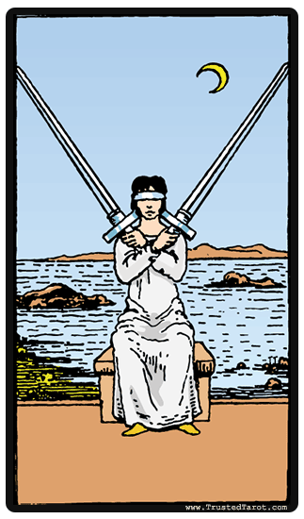  TWO OF SWORDS | Tension in relationships. Indecision. Balanced forces. Military friendships. A well-developed sense of balance and rhythm but needing direction. Stalemate.
3 | 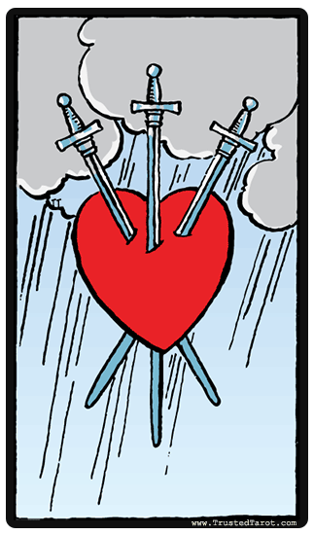  THREE OF SWORDS | Stormy weather for the affections. Tears, separation, quarreling. A general upheaval of the environment. Possibility of civil war. Political strife.
4 | 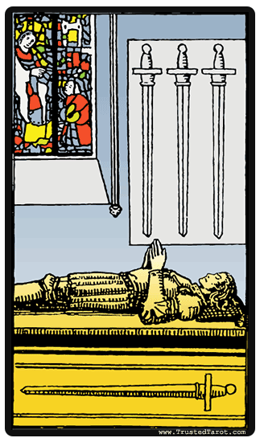  FOUR OF SWORDS | Hermit’s repose. Rest after war. Banishment. Relaxation of anxiety, release from suffering. There will soon be a change for the better. Not a card of death.
5 | 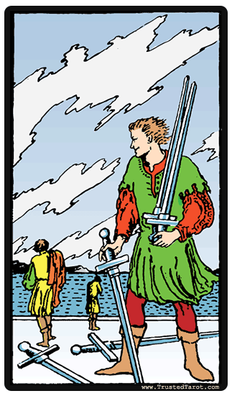  FIVE OF SWORDS | Failure, defeat. Degradation. Conquest of others. Unfairness, slander, cruelty, cowardliness.
6 | 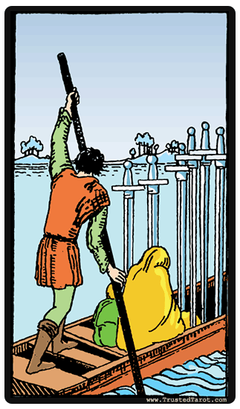  SIX OF SWORDS | The future will he better. Success after anxieties. Journey to a new home, by water. Sending someone to represent you in an undertaking. Also a journey in consciousness.
7 | 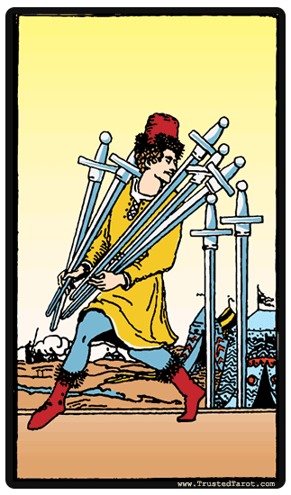  SEVEN OF SWORDS | A plan that may fail. An unwise attempt to make away with what is not yours. Unstable effort. Arguments over plans. Spying on another. Partial success.
8 | 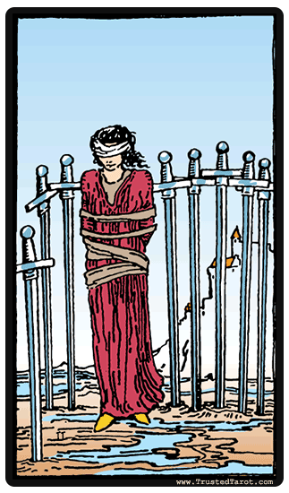  EIGHT OF SWORDS | Narrow or restricted surroundings. Bondage. Imprisonment through indecision. Betrayal. Fear to move out of a situation. Temporary sickness.
9 | 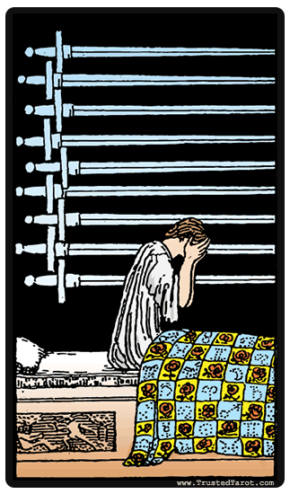  NINE OF SWORDS | Suffering, loss, misery. Burden, oppression. Doubt and desolation. Illness. May mean death of a loved one.
10 | 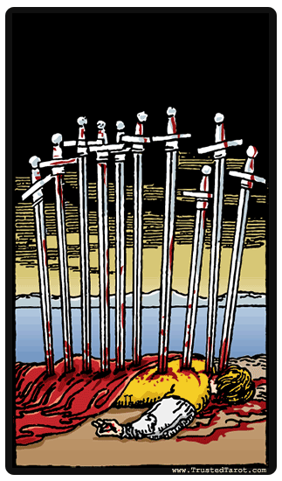  TEN OF SWORDS | Though the Nine of Swords showed despair, the meaning here is even more serious. Ruin of plans and projects. Defeat in war. Disruption of home life. Tears will fall. Trouble will come in spite of riches and high position. Not a card of violent death. A suggestion to give charity freely to those in trouble.
11 | PAGE OF SWORDS | A young person who might be a page in the diplomatic or government service. He or she already has great understanding and knows how to use diplomacy. This card can also mean a message and certain types of spying, as well as grace and dexterity.
12 | 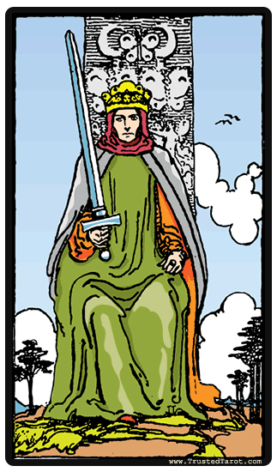  KNIGHT OF SWORDS | A dashing, brave young man. Though he may be domineering, he has a clean heart and is full of courage. The card may also mean the coming or going of misfortune.
13 | 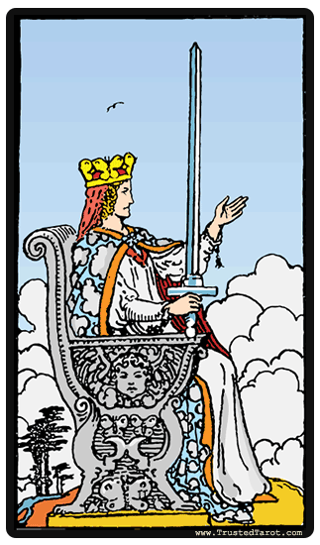  QUEEN OF SWORDS | A subtle, keen, and quick-witted woman who may represent a widow or one who is unable to bear children. Perhaps she is mourning for those she loves who are far away from her. This card may mean widowhood, mourning, privation. Kindness but also firmness. Keen observation. Gracefulness; fondness for dancing.
14 | KING OF SWORDS | This is a man who may be a lawyer, a judge, a general, or a governor. He gives wise counsel, is firm in enmity as well as in friendship. A man of many ideas, thoughts, and designs. The card may also mean power, strength, authority, or military intelligence. A lawsuit is in the offing.

THE SUIT OF PENTACLES
S/N | CARD | MEANING
1 | 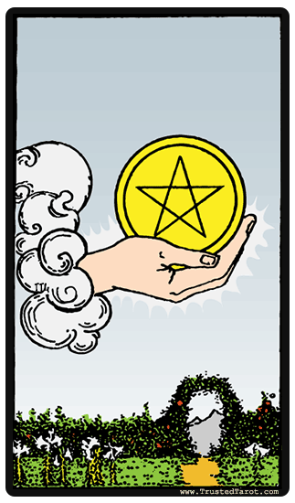  ACE OF PENTACLES | The beginning of wealth and material gain. Gold, prosperity, combined with pleasure and beauty.
2 | 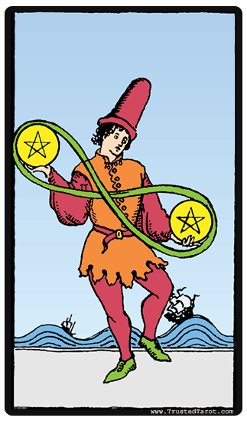  TWO OF PENTACLES | The ability to juggle two situations at one time. Lightheartedness, gaiety. Recreation. Harmony in the midst of change. New projects may be difficult to launch. News and messages in writing. A nature industrious yet unreliable, elated and then melancholic.
3 | 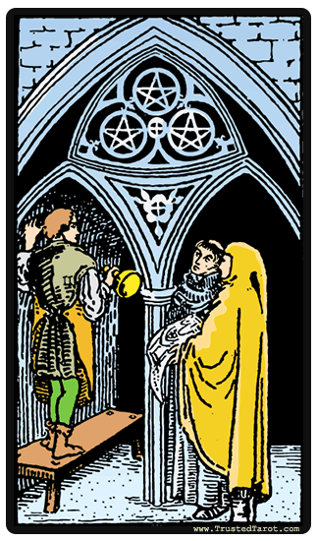  THREE OF PENTACLES | Material increase. The master craftsman, the skilled artist. Gain in a commercial transaction. This is the card for members of the Masons and other groups and societies.
4 | 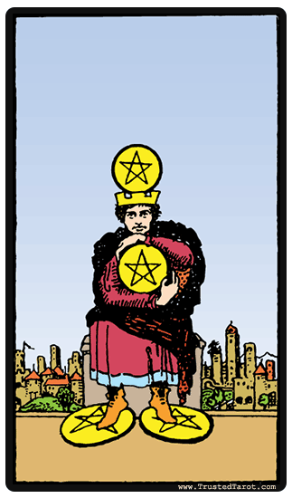  FOUR OF PENTACLES | Assured material gain, success. Earthly power, but leading to nothing beyond it. Gifts, legacy, inheritance. May indicate a miserly, ungenerous character.
5 | 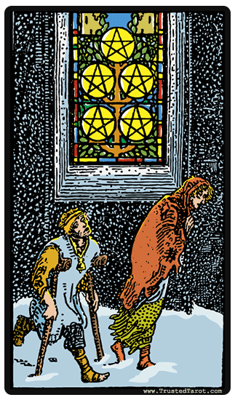  FIVE OF PENTACLES | Unemployment, destitution. Loss of home. Loneliness. Lovers unable to find a meeting place. Affinities discovered through similar troubles. Dark night of the soul.
6 | 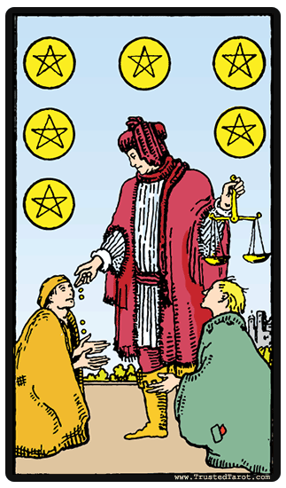  SIX OF PENTACLES | Alms dispensed with justice; gifts, inheritance. Gain in material undertaking. Others will share with you justly. You will receive what you deserve.
7 | 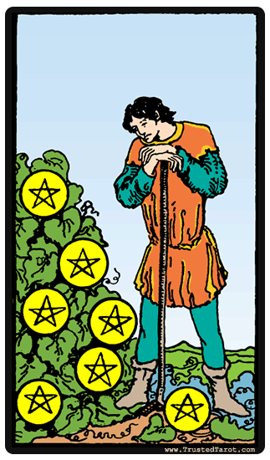  SEVEN OF PENTACLES | Pause during the development of an enterprise. Unprofitable speculations. Loss of promising fortune. Disappointment. Anxiety about a loan. Success not attained.
8 | 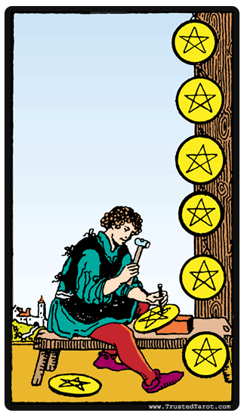  EIGHT OF PENTACLES | Learning a trade or profession. The beginning of a profitable undertaking. Employment or commission to come. Skill in material affairs, handiwork, and the arts -sometimes remaining only in the apprenticeship stage.
9 | 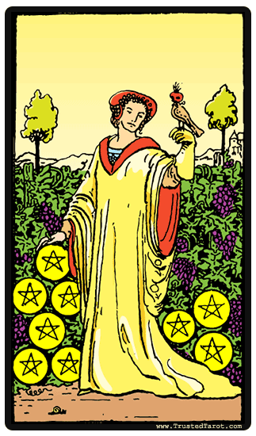  NINE OF PENTACLES | Solitary enjoyment of the good things of life. Inheritance. Wisdom where one’s own interests lie. A person and a green thumb. Material well-being. Caution: be prudent. Great love of gardens and home.
10 | 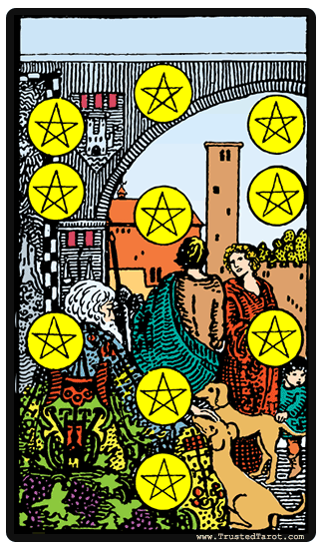  TEN OF PENTACLES | Riches, inheritance. Attention to family matters, interest in one’s ancestral tree. A problem concerning a will or pension. May refer to the acquiring of a house or a business property.
11 | 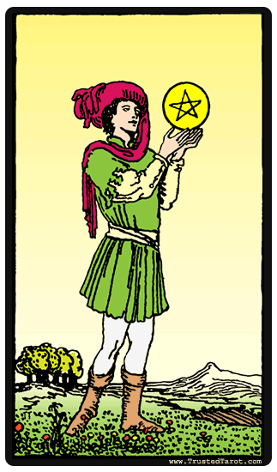  PAGE OF PENTACLES | Respect for learning and new ideas. A scholar. A typical introvert. Can also mean application; reflection. Good management, carefulness. The bringer of good news and messages about money.
12 | 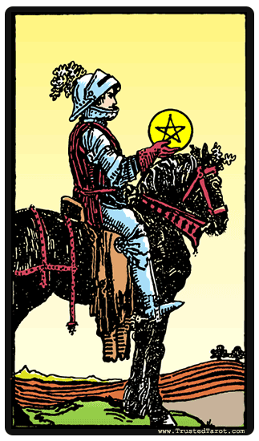  KNIGHT OF PENTACLES | A man of upright nature who accepts responsibility. He is laborious and patient. The card can also mean utility, serviceableness, trustworthiness. Or the coming or going of an important matter connected with money.
13 | 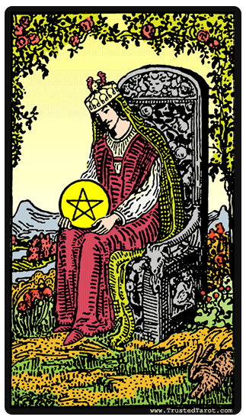  QUEEN OF PENTACLES | This is a woman who is the Earth Mother, generous with her gifts. She is rich but charitable, a truly noble soul. A creator on the physical plane. Other meanings are opulence; security. Trust of those around one. At times melancholy or moody. Good use of practical talents.
14 | 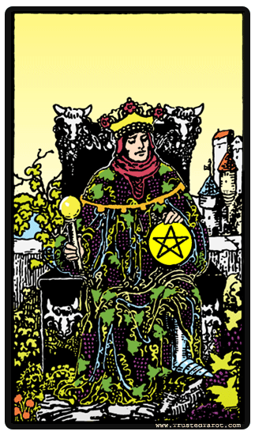  KING OF PENTACLES | This is a chief of industry, a banker, or owner of large estates. He is a reliable married man and a mathematician with great financial gifts. The card can also betoken a steady temperament, slow to anger; success where money matters are concerned and reliability.

MODULE THREE QUIZ
- How many cards in total the Minor Arcana?
- 56
- 22
- 78
- 66

- Minor Arcana is further divided in to four suits namely;
- Pentacles, Swords, Cups, Wands
- Pentacles, Knights, Cups, Wands
- Pentacles, Swords, Clubs, Wands
- Ace, Swords, Cups, Wands

- Which card points to the beginning of an enterprise?
- Ace of Pentacles
- Queen of Swords
- Knight of Cups
- Ace of Wands

- Which card points to a plan that may fail?
- Nine of Swords
- Seven of Pentacles
- Seven of Swords
- Ace of Cups

- Which of the following shows the ability to juggle two situations at one time?
- Two of Pentacles
- Three of Swords
- Page of Cups
- King of Swords

MODULE FOUR
DIFFERENT SPREADS IN TAROT AND THEIR MEANING

INTRODUCTION
There are a lot of reasons surrounding why people turn to tarot cards, especially in comprehending happenings in their life. However, one cannot argue the results of what the cards contributes in solving the core problems in the hearts of individuals. The beauty in this course is that you can gain access to learning how to read the different spreads of the tarot cards yourself. Before you start out on that, it will be help to hold on to the following;
- A private and quite place is advised as a good location to set up as your Tarot work place. Disturbance of any sort should be kept outside that space.
- The ray of light entering the room should be minimal, preferably dim. You can use curtains to block the light ray and not block the flow of air.
- There has to be an uttermost form of concentration while you shuffle the cards. You may get the wrong card if this is not diligently considered. As the reader, you need to focus on the cards and the question that needs to be answered.
- One of the most important things to remember, is to never cross your legs or arms. This is required of everyone present in the room. It is a posture not allowed while at the tarot card table.
- The deck of the cards needs to be cut by the person asking the question, with his or her left hand.
- After reading the cards, collect the set, and place it in a corner that is dark and silent. It is important that the cards are always handled by the card reader, as there is an energy associated to this.
CARD SPREADS AND MEANINGS
The tarot deck can be spread in different kind of ways, each with a custom meaning attached to it. It is the interpretation of these spreads that the reader uses in predicting the future for the querent who has come to consult. Six of these spreads are explained below, with their meaning.
Relationship Spread
In this layout, the cards are indicative of the person’s relationship with people in his life. The spread is such that, the first row is made of the cards 9 and 10. After this row lies card number 6, which is placed in the center of the two cards placed earlier. Then, there is a row of five cards namely, 1, 2, 3, 4, and 5 placed in that order. The last row is again made of two cards, 8 and 7; the placement of the cards will be the same as cards 9 and 10.
Card number 1 indicates the distant past, while card number 2 represents events that have happened recently. Cards 3 and 4 are representative of the person’s present and the influences on the future. Card 5 indicates the influences that the person has no control over. Card number 6 signifies how the seeker sees the situation, card number 7 symbolizes those energies that are helping the situation, and card number 8 indicates the hurdles in the querent’s path. Card number 9 is representative of the hopes and fears that the person feels, and card number 10 represents the outcome to be expected.
Mirror Spread
This layout helps assess relationships in the life of the person, who is consulting the reader. The spread, as the name suggests, is symmetrical, with one half of the complete layout mirroring the other half. The layout has eight cards with two columns of three cards each, and two cards, one at the top and one at the bottom, between the two columns. Cards 1 and 8 are the two cards at the top and bottom of the layout, the column on the left has the cards 2, 4, and 6, and the column on the right has the cards 3, 5, and 7. Card number 1 is indicative of the person asking the question, card 2 represents the other person in the relationship, card 3 indicates how the querent views himself, card 4 indicates what the other person means to the one asking questions, and card 5 represents what he/she means to the other person. Card 6 symbolizes the hurdles in the relationship, card 7 represents the strengths of the relationship, and card 8 indicates what the relationship’s outcome will be.
Mandala Spread
This spread is one of the layouts that helps answer questions about one’s spirituality. It is indicative of one’s strengths and weaknesses that helps or hampers your spiritual growth. In order to make sense of this spread, one needs to read card number 1 in view of cards 2, 4, and 6 to understand what the situation is, and then read card number 1 in combination with cards 3, 8, and 9 to understand the future. Then, reading card number 1 in view of cards 5 and 7 will help you assess the potential problems in your path.
The cards are laid out to resemble a diamond with card 9 at the top, cards 8 and 2 making up the next row, cards 7, 1, and 3 making up the center row, followed by a row made up of cards 6 and 4, and then card number 5 at the bottom of the diamond. Card 1 is indicative of what the person is like, card 2 is representative of one’s ambitions, card number 3 showcases one’s ideals, card 4 outlines one’s achievements, card 5 portrays one’s dependencies, card 6 is representative of the positives of a person, card 7 indicates one’s faults and weakness, card 8 is representative of what one thinks of oneself, and card 9 indicates one’s desires.
Five Card Spread
Another popular layout is the five card spread. As the name suggests, there are only 5 cards used in this layout with the spread being similar to the Celtic cross spread, without the parallel column of four cards. Card number 1 indicates the present and the question being asked. Card number 2 is representative of the past and the influence it has on the question being put forward. Card 3 indicates the future of the person, and card number 4 points out the reason behind the question. Card number 5 gives a semblance of a solution by providing a potential within the question.

Ellipse Spread
If you want to know what the outcome of a project that you are involved in will be, then one of the best layouts to consult is the ellipse spread. The cards are spread out in such a manner that they resemble the alphabet V, starting with card number 1 at one end, card number 4 in the center, and card number 7 at the other end. Card number 1 is the representative of your past, card number 2 indicates the present, and card number 3 represents the future. Reading cards 4, 5, 6, and 7 will give you an indication of what solution you have at your disposal, what harm you can come to, what are the hopes and fears associated, and what is the outcome of the problem.
Celtic-Cross Spread
The Celtic-Cross layout is widely regarded as one of the easiest tarot spreads for beginners to learn. It is also quite a detailed spread. The spread is arranged with nine or ten cards depending on the preference of the reader. The placement of the cards is such that, card number 1 is placed in the center with card number 2 placed horizontally, on top of it. Card number 3 is placed to the right of card number 1, and card number 4 is placed below it. Card number 5 is placed parallel to card number 4 and card number 6 is placed to the left of card number 1. Cards 7, 8, 9, and 10 are placed parallel to the column created by cards 1, 3, and 5, with 10 at the top and card number 7 at the bottom.
Card number 1 represents the present. Card number 2 is representative of the present obstacle that the person asking the question is trying to overcome. Card number 3 symbolizes the past and the foundation for the question being asked. Card number 4 is indicative of recent events that have a direct connection to the question. Card number 5 represents what may be the best solution to the question asked. Card number 6 represents the immediate future, and card number 7 is representative of what the consultant’s emotions are about the situation at hand. Card number 8 indicates what external factors influence the situation, and card number 9 is representative of the hopes and fears pertaining to the situation. Card number 10 is representative of the outcome that you can expect.

MODULE FOUR QUIZ
- Which of the following is not a healthy tip while performing a Tarot reading?
- Keep the light in the room dim
- Fold your legs and also your arms always
- The reader should be in control of the cards and not the querent
- The deck of cards needs to be cut by the querent

- What spread shows what the outcome of a project that you are involved in will be?
- Ellipse Spread
- Celtic-Cross Spread
- Mirror Spread
- Mandala Spread

- Which of the spreads points to one’s spirituality?
- Mandala Spread
- Relationship Spread
- Celtic-Cross Spread
- Mirror Spread

- Which of the spreads is symmetrical?
- Ellipse Spread
- Mirror Spread
- Mandala Spread
- Five Card Spread

- Which of the spreads uses just five cards?
- Mirror Spread
- Ellipse Spread
- Relationship Spread
- Five Card Spread

MODULE FIVE
HOW TO DO READINGS PROFESSIONALLY

CARD PRESERVATION
You cannot begin to read if you do not know how to preserve your tool of workmanship. This is typical for professionals in every field, to be able to preserve the tools they use to work. There would be no work without work tools. Hence, it is of good measure to the reader when they know how to preserve the tarot cards. This protection is not only from physical damage but also from discordant vibrations. As a professional reader, you know the relations between your cards and the energies emitted. Therefore the need to protect from external energies is a need.
Any piece of silk material will be favorable. All you have to do is wrap the material around the card. An old silk material is more preferable, it could be a scarf. After this, once can now put it into a small box. Under no circumstances should the cards be left just lying around scattered. Some persons also find putting it under their bed pillow suiting especially when it is new. This practice is done for couple of nights in other to connect with the energy the card emits.
PREPARING YOURSELF AS THE READER
It is important that you study and really learn the meanings of each of the 78 cards. In some way that many do not understand, your subconscious mind seems to direct the shuffling but can do this correctly only after you have implanted the meaning of each card in your memory. Before you try to read for a friend, also familiarize yourself with the method of laying out the cards that you have decided to use. Half-learned meanings will result in half-correct answers. Do not encourage levity in any of those present, for a reading is a serious attempt to go above the psychic realm to a higher level where Truth is accessible. As a matter of precaution, you do not have to take the first few of your readings too seriously. In reading for yourself, be particularly careful that a happy mood does not incline you to over-rosy interpretations; likewise, if you are blue and discouraged, be sure to check how much your mood is affecting your reading.
SHUFFLING AND CARD LAYING
If you have read through all the meaning of the 78 cards, it is also important to note that these meanings can be revered. This, of course, means when the card is upside-down. A card in this position usually yields the opposite meaning to that of the card when right side up. If you are going to shuffle by riffling, then hold the cards so that the tops in each hand face each other. In this way they will be well mixed, with approximately half the cards facing in opposite directions. As they are shuffled again and again for each reading, they become very well mixed.
You as the person engaging in the reading is referred to as the Reader, and the person for whom you are going to read is the Querent. Before any shuffling is done, choose a Court card that corresponds to the age and coloring of the Querent. For example, choose a Page for boys under twenty-one and girls, too (unless they are married, in which case a Queen is chosen for them). Select a Knight for a young man; a King for a married, mature man; a Queen for any woman over twenty-one. Look up the descriptions of the Court cards and find one that is suitable. But do not, at this stage, attach too much importance to the card chosen. If the Querent feels she is the Queen of Wands in temperament, even though her hair is dark, it is quite all right. The Hierophant might be a good choice for a clergyman; the Emperor might be chosen for an important political figure.
(Follow the directions given with the spread you have selected. We discussed different kind of spreads in the previous module. It may direct you to put the Querent’s card in the center of the spread or to place it back in the deck.)
It is best that the Querent shuffle the deck, but if this seems impractical, the Reader may do so, asking the Querent to lay his hands on the deck before cutting it. While shuffling, the Querent should ask, silently, a simple but important question, repeating it over and over again mentally until he feels the question has entered the cards. It is best if the Reader does not know what the question is, since this knowledge might color his reading unduly. During the shuffling the Reader should silently ask that only the highest forces surround them. Later, when the reading is nearly finished, the question can be told and the cards then gone over for amplification. After shuffling, the Querent cuts the cards into three piles, with the left hand toward the left, in true Gypsy fashion. The Reader then picks up the piles with the left hand, starting with the first pile put down.

HACKING THE SPREADS
The cards from the top of the deck should be turned face up one by one and placed in an order corresponding to the diagram selected. When the requisite number of cards are laid out, the rest of the pack is put aside and not used. Glance quickly at all the cards laid out, and note if there is a preponderance of any one suit or if there are many Court cards or cards of the Major Arcana. These will indicate a general trend or direction in the readings.
- MANY WANDS: Change
- MANY CUPS: Love, goodness
- MANY SWORDS: Strife
- MANY PENTACLES: Political action or intrigue
The presence of many of the Major Arcana indicates that the answer to the Querent’s question is largely controlled by other people. Remember that readings depend not only on the meaning of the individual card but also on its place in the layout, and that the cards on each side may also affect the interpretation.
Questions usually fall into one of the following categories:
- Love, marriage, family situations
- Money, business affairs, property
- Personal accomplishment, travel
- States of mind; problems encountered on the spiritual plane

HOW TO INTERPRET THE CARDS PROFESSIONALLY
An experienced reader would start by trying to make a running story about what they see in the cards in relation to the person for whom they are reading. As the reader, if you have forgotten the meanings of some of the cards, look them up - don’t guess.
If, after reading the cards, the Querent tells you that his question is not answered, ask him if the cards have perhaps dealt with a deeper question that he has been worrying about. It has been found that people are sometimes a little timid about bringing out into the open what is really on their minds, and will ask a superficial question of the Tarot. With a little digging and a sincere desire to help, you may uncover what is really bothering the Querent and find that the cards have indeed answered a question that really was uppermost in his mind.
Perhaps you are psychic; the cards then will really come alive for you and lead you right to the problem about which the Querent needs to talk and get advice. Those who do not feel that they are psychic will soon find, however, that they are developing a sixth sense and that they intuitively feel the inner implications of the situation. Sometimes the cards do not seem to be responding at all. In that case, ask the Querent to shuffle again and concentrate more deeply on the question. If, on reshuffling, the cards still do not make sense, it would be well to put them away for at least twenty-four hours before trying to read them again.
As a caution, do not finish the reading on a discouraging note. If the cards reveal something bad, indicate how the Querent can overcome the problems by work, study, application to tasks, better care of health, or by expending more love and compassion in relationships. You may foretell (but only in a vague manner) the possible illness or death of someone the Querent knows, but never predict a serious illness or death for the Querent. Instead, say you see the possibility of a slight illness in the future, which could be avoided if the Querent would take better care of his health, and then quickly move on to interpreting a more positive section of the layout.
Reading the Tarot is a great responsibility. It gives you the opportunity to help others gain an insight into what may be holding them back from their fullest self-expression. Other people are as sensitive as you are, and giving a discouraging reading with no hope held out for the future is a cruel and pointless thing to do. Besides, we have all seen seemingly hopeless lives suddenly take remarkable turns for the better. While there is life, there is always hope.
Yes, you have made it to the base of the course, you now have the responsibility to use this new found exposure of knowledge as you see fit. Go good on it.

MODULE FIVE QUIZ
  - When your spread has many wands, what is the general direction of reading?
- Productivity
- Accountability
- Feelings
- Change

  - When reading the cards it is better to start with a story.
- True
- False
- None of the above
- All of the above

  - A querent’s question may fall under the following category except?
- Love
- Family
- Personal Accomplishment
- None of the above

  - When your spread has many wands, what is the general direction of reading?
- Strife
- Anger
- Relationship
- Career

  - Which material is best used for protecting the tarot card?
- Suede
- Polyester
- Cotton
- Silk

